PROJECT

Voice Controlled LEDs using Arduino and Bluetooth

Controlling LEDs with voice command seems to be a difficult task, but it’s easy and you can quickly build it. We just need an Arduino UNO to serially communicate with HC-06 Bluetooth module and a smartphone to send voice command to Bluetooth module HC-06. For receiving voice command we are using “Arduino Bluetooth Voice Controller” android app which you can download from play store

Circuit and Working

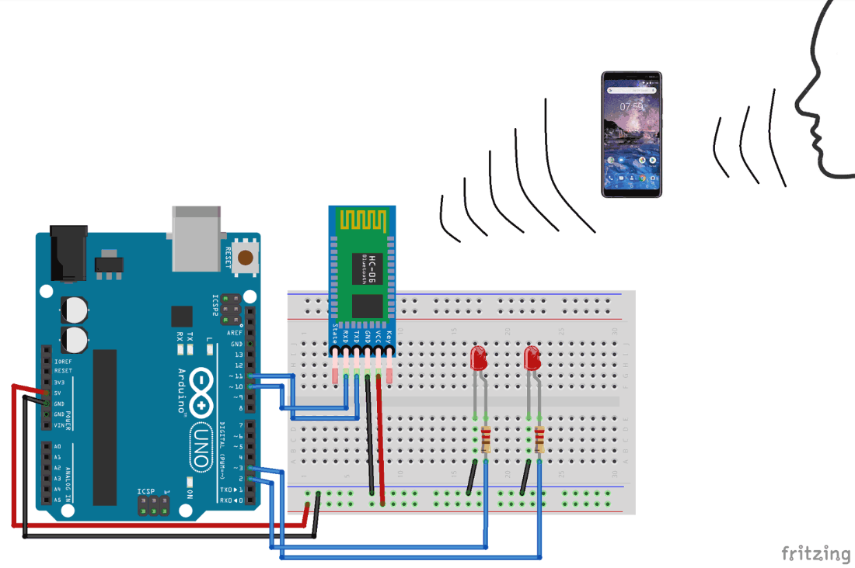

PIN CONNECTIONS

connect TxD to 11 (blu module to arduino)

connect RxD to 10 (blu module to arduino)

vcc to 5v and gnd to gnd

led connections:

red led to pin 2

green to pin 3

and negative to gnd

WORKING

**Step 1**:- Connect all components as per the circuit diagram; disconnect Rx and Tx pins while uploading the code.

**Step 2**:- Download the app called “Arduino Bluetooth Voice Controller” which is free on play store.

**Step 3**:- Open the app and follow the image below, like first click on “connect to Bluetooth device” and select your Bluetooth module and check if it is connected or not. Then click on the mic icon to speak and send the voice command to the HC-06 module.

***Note: when you are connecting your Bluetooth module for the first time with your smartphone it will ask for the passcode, use 0000 or 1234.***

**Step 4:-**After setting up all the things, you just have to send the voice command by using the app which is further sent to Bluetooth module HC-06 and the HC-06 serially communicate with the Arduino UNO and then the task is performed as per the command. The below shows the command and the action to be performed by the command:

|  |  |  |
| --- | --- | --- |
| **S. No.** | **Command** | **Action** |
| 1. | all LED turn on | Both Red and Green LED turns ON |
| 2. | all LED turn off | Both Red and Green LED turns OFF |
| 3. | turn on Red LED | Red LED turns ON |
| 4. | turn on green LED | Green LED turns ON |
| 5. | turn off red LED | Red LED turns OFF |
| 6. | turn off green LED | Green LED turns OFF |

CODE

#include <SoftwareSerial.h>

String value;

int TxD = 11;

int RxD = 10;

int servoposition;

SoftwareSerial bluetooth(TxD, RxD);

void setup() {

pinMode(2, OUTPUT);

pinMode(3, OUTPUT);

Serial.begin(9600); // start serial communication at 9600bps

bluetooth.begin(9600);

}

void loop() {

Serial.println(value);

if (bluetooth.available())

{

value = bluetooth.readString();

if (value == "all LED turn on"){

digitalWrite(2, HIGH);

digitalWrite(3, HIGH);

}

if (value == "all LED turn off"){

digitalWrite(2, LOW);

digitalWrite(3, LOW);

}

if (value == "turn on Red LED"){

digitalWrite(2, HIGH);

}

if (value == "turn on green LED"){

digitalWrite(3, HIGH);

}

if (value == "turn off red LED"){

digitalWrite(2, LOW);

}

if (value == "turn off green LED"){

digitalWrite(3, LOW);

}

}

}

